Custom EEO (Applicant Flow) Report
State of Louisiana
This report can be used to gather EEO data for your Affirmative Action Plans. NOTE: This report is only as accurate as the information entered into the system. The report pulls data from both Insight and OHC. Therefore, it is extremely important to record accurate interview, reject and hire information in OHC. Please refer to the OHC Workflow Quick Sheet for specific instructions on recording this information properly.
**It may be helpful for you to first run the Hires by Date report (Hires ➔ Hires by Date) so that you will know exactly from which postings your hires were made during the period for which you want to gather EEO data.

To run the Custom EEO (Applicant Flow) Report:

- Log into Insight, select: Reports/Standard/Custom/Applicant Flow.
- For the first section, “Include Job Postings”, you may want to select ‘All’ so that you capture all job postings, regardless of their current status.
- In the “Department” section, choose the department(s) for which you want to gather data. If you have access to multiple departments within your agency, you can select more than one department at a time by holding the ‘Ctrl’ key and clicking additional departments.
- Select one or more EEO Codes using the ‘Ctrl’ key. Most state agencies will select among the EEO4 categories as these are for governmental entities. EEO1 categories are applicable to private industry while EEO6 are used by educational institutions.
- Select one or more Occupational Groups using the ‘Ctrl’ key. The list of names corresponds to the labels assigned to the various occupational groups assigned to job titles in the Civil Service pay plan (e.g., A1=Clerical and Records; B1=Accounting and Auditing, etc.). This information may help you in deciding which Occupational Groups to select or you may select “All” if you are unsure.
- Click the ‘Filter’ button.
  - This will find all postings which match the criteria you have selected above and display them in the “Job Posting” field.

==See example on next page==
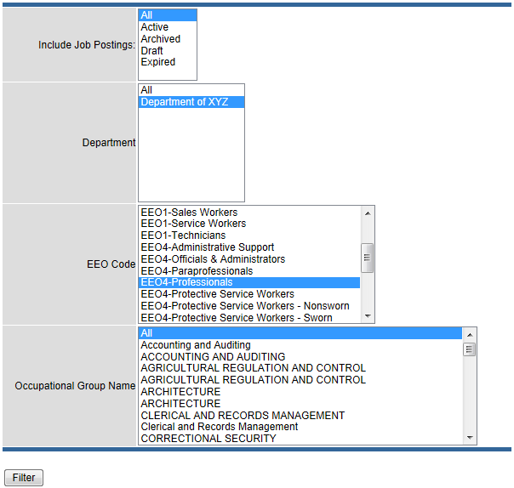

- Now you are ready to select the posting(s) for which to run the report.
  - Choose one or more postings (by holding the ‘Ctrl’ key) in the “Job Posting” field.
  - NOTE: You should only choose postings for which hires have been made.
- Enter a Start Date.
- Enter an End Date.
NOTE: When selecting the Start Date, you will want to include the earliest posting open date from your Hires by Date report. For example, for the time period I would like to report of 6/01/2013-5/31/2014, the first hire was made June 8, 2013. However, the posting from which this hire was made opened on April 12, 2013. Therefore, 04/12/2013 should be the Start Date for the EEO report. The Start/End Date are application received dates.
- For the “Include Applications” field, choose either ‘Active’, ‘Archived’ or ‘All’.
- For the “Report Summary” field, select either ‘Summary’, ‘Details’ or ‘Both’.
  - Summary = the numbers of applicants through the various stages of the recruitment process broken down by gender/race/ethnicity. This is likely all you need when gathering data for your Affirmative Action Plan.
  - Details = each step achieved for each applicant by name (no numbers included).
- Click ‘Generate Report’.
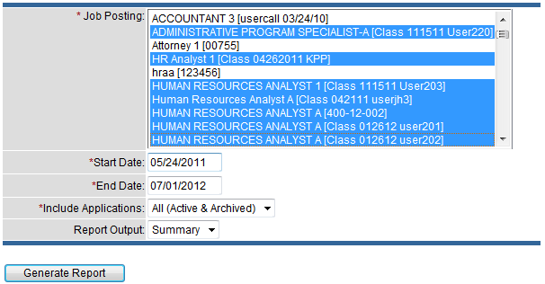
You will then see the following message on your screen:
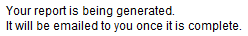

The report may take several minutes to generate depending on the number of records in the postings selected. The e-mail will contain your report in an Excel spreadsheet as an attachment. The e-mail will be delivered from the address support@neogov.net and may appear in your junk/spam folder. You may need to add this address as a “Safe Sender”.

