State of Louisiana Notice Template Quick Sheet
Civil Service has created some generic templates for agencies to use, but you are also able to create your own agency-specific notices. Remember you are required to send notices to applicants who do not meet the minimum qualifications. Sending additional notices when the vacancy is filled or for other reasons may help reduce the number of applicant calls.

Most users send notices from the Insight side of the system, but you can also send them from the OHC if you choose. You create the templates for both in Insight.
- To create a template, click the ‘Library’ button, then the ‘Notice Templates’ link.
- Select ‘Add New Template’ at the top of the page.
- Enter a Name for the template. This name will appear in a drop down menu for you to select when you are sending notices, so make sure to name it in a manner you can identify. For example – [agency name] [notice name] – DSCS Does Not Qualify.
  - Applicants will not see the name of your template.
- The template description field is optional. Applicants will not see this information.
- Enter a Subject for your template.
  - Applicants will view the subject. This is like the subject line of an email. Please take care in how you word these statements.
    - For example, instead of using an abbreviation such as DNQ, you may want to use ‘Application Status’ or something equally generic.
- DO NOT choose a Reject Reason. Leave this drop down on ‘==Select==.’ Otherwise users will not be able to select their own templates when sending notices.
- The ‘Template’ section will contain the body of the notice. Civil Service recommends that you copy and paste the Example Template immediately below into this box. When doing so, it is recommended that you remove “Any request for reconsideration must be made in writing immediately” from your template.
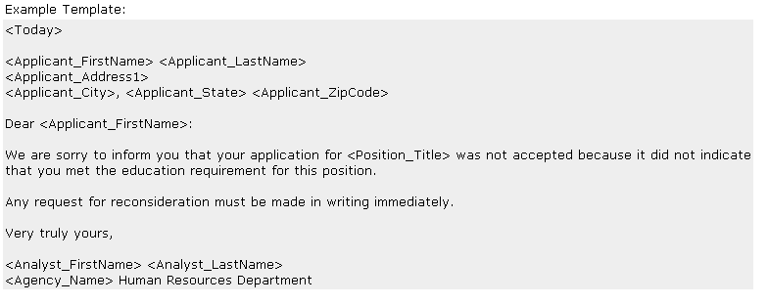
  - The information contained in these symbols <text> are html codes, and will prompt the system to insert certain information. For example, when you see <Today> in the template, the date you send the template will show on the actual notice you are sending out.
  - You may leave the heading information as-is through ‘Dear <Applicant…”
  - Change the header and/or text of the notice to meet your needs.
    - There are many additional html codes listed on the remainder of the Notice Template page for your use.
    - Please include the <Position_Title> code and any other applicable identifying information (such as the closing date) in your template so that applicants will know which job the notice is referencing.
    - Notices informing candidates that they do not meet the minimum qualification requirements can be generic in nature and do not need to include detailed information about the specific experience or education that is lacking.
  - Change the closing to meet your needs.
    - Due to LA Careers configuration, <Agency_Name> will pull in ‘State of Louisiana’ and not your specific agency. As this is your agency-specific template, you may either type your agency name directly into the template or copy/paste <Req_Department> from the requisition merge fileds section.

