State of Louisiana Filtering Quick Sheet
There are three (3) ways the Advanced Filter may be created in Insight and this Quick Sheet will address each individually. It is important to note the difference between the reasons for using this function in the evaluation steps and using it in the eligible list:
- Evaluation Steps - screen for MQ or find applicants who have indicated an exemption from a required written test.
- Eligible List - Identify “best qualified” applicants based on responses to supplemental questions.

- Creating Advanced Filter From the Exam Plan Page
  - In the Advanced Filters section of the exam plan, click either ‘Add Evaluation Step Filter’ or ‘Add Eligible List Filter’. Once created, the filter will be available only in the corresponding section.
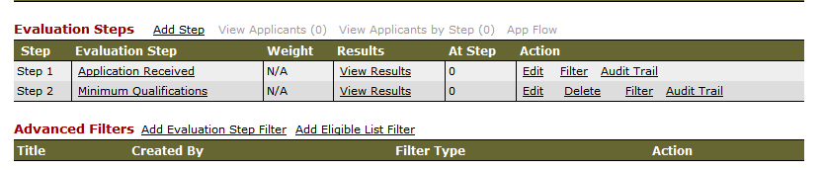
  - Enter a descriptive name into the Name field.
  - DO NOT select the Share Filter box.
  - For Object, select the appropriate type of question. In most cases, you will either select Agency Wide Questions (on the standard application form) or Supplemental Questions (the job-specific questions you created).
  - For Field, select the question for which you would like to run the filter.
  - For Operator, select the function that will yield the records that you're expecting to see.
    - For exact matches, select Equal (=). The filter will return only those applicants who answer this question with the single response you choose in the Value field.
    - For multiple responses, use the Contains (IN) operator. The filter will return applicants who select any of the multiple responses you choose in the Value field. Choose multiple responses by holding the Ctrl key while clicking.
NOTE: Depending on what you select as your Object, you may see a wide variety of Operators from which to choose. For example, if you choose Application as your Object, and Date Received as the Field, you can choose Operators which will find applications submitted on, before, between or after specific dates. This may be helpful when processing a continuous posting with a large number of applicants.
  - For Value, select the answer choice(s) for which you are basing your search.
  - If your filter contains only one search condition, you are ready to click ‘Save’. However, if you would like to refine your search by filtering on multiple questions at the same time, click ‘Add Condition’ and set the parameters for your next question.
  - Notice that your subsequent condition lines are connected with AND/OR logic. Change these values to best suit your needs.
    - Selecting ‘OR’ is a broad filter (ex: applicant can answer EITHER Question 1 this way OR Question 2 this way).
    - Selecting ‘AND’ is a more specific filter (ex: applicant MUST answer Question 1 this way AND Question 2 this way).
  - Once you have completed your entire filter statement, click ‘Save’.
  - Upon saving, you are returned back to the exam plan page and you will be able to see the filter(s) where you can view, edit or delete. Please DO NOT click the ‘Share’ link.

Below are some examples to give you a better understanding of how to construct your own filter statements.

Filter Example #1
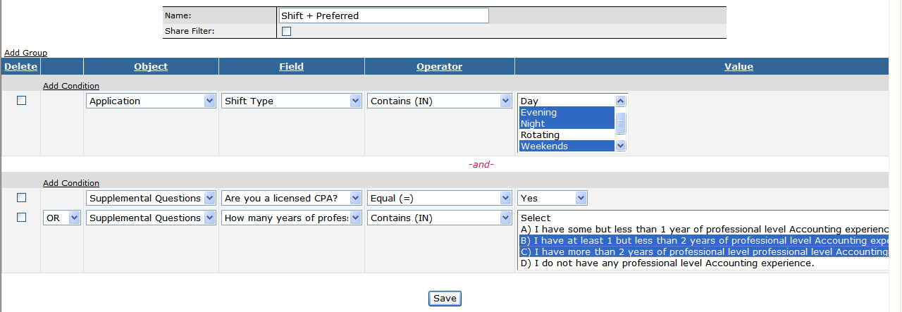
This filter will find applicants who indicated on their application they are willing to work Evening, Night or Weekends
AND (set up by using the ‘Add Group’ feature)
Answered Yes to the CPA question OR stated they have either at least one year or at least two years of experience.

Filter Example #2
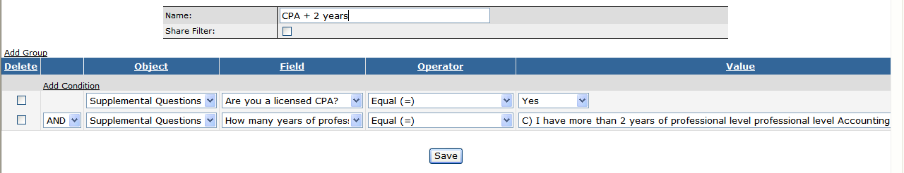
This filter will find only those applicants who answered Yes to the CPA questions AND who indicated they have at least two years of experience.

- Creating Advanced Filter From the Evaluation Step
  - Open the evaluation step at which you would like to execute the filter.
  - For Select Action, choose Advanced Filter.
  - For Select Candidates, choose the applicable candidate value for your filter (e.g., All).
  - Click the red ‘Go’ button.
  - Click the ‘Add Filter’ link.
  - Repeat steps B-J from Part I above.
  - Upon saving, you are returned back to the page allowing you to apply, or execute your Evaluation Step filter; click Apply.
  - Your Evaluation Step will display, THIS STEP IS FILTERED.
  - After your application records are filtered, you can carry on with other tasks such as changing disposition values, sending notices, etc.

- Creating Advanced Filter From the Eligible List
  - View the candidates who have been placed on the eligible list.
  - For Select Action, choose Advanced Filter.
  - For Select Candidates, choose the applicable candidate value for your filter (e.g., All).
  - Click the red ‘Go’ button.
  - Click the ‘Add Filter’ link.
  - Repeat steps B-J from Part I above.
  - Upon saving, you are returned back to the page allowing you to apply, or execute your Eligible List filter; click Apply.
  - The eligible list will then display, “Filter returned -- records”. If the number is anything greater than zero (0), you will see the names of the applicants meeting the criteria of the filter.
  - You can now continue processing these applicants accordingly (e.g., refer, e-mail notify, etc.).

IMPORTANT! It is strongly recommended that you consult with your Staffing representative prior to using the Advanced Filter for the first time. We will help you ensure that your supplemental questions and filters are designed to be the most beneficial to you.

