Evaluation Step Configuration for Candidate Display

The following steps describe the new functionality for displaying information about the evaluation step process to the candidates on the applicant profiles. Each agency may decide what information to display, and when to display it.

Civil Service has configured the test exam plans so that applicants will be able to view their test scores. Please DO NOT edit any of the test evaluation steps that populate into your individual exam plans. You may use this functionality for the Application Received, MQ and any other evaluation steps that you add.

The display step options will default as un-checked and you will have to edit the evaluation steps if you want to display this information.
- Application Received
  - From the exam plan, select ‘Edit’ in the evaluation steps section across from the Application Received step.
  - Select the checkbox for ‘Show Step Pass/Fail’
    - This will display as a link that says ‘Application Received’ which the applicant can click to see whether or not they passed or failed.
- MQ Review and/or other steps added by the agency
  - From the exam plan, select ‘Edit’ in the evaluation steps section across from the MQ Review step.
  - The information entered into the Display Candidate Status As field will show as the status link the applicant can select to view additional status information.
  - The information entered into Step Name will show in the Evaluation Step column after the applicant selects the status link. If you do not enter a step name, the Step Type will show here, so we recommend you enter a name that will describe the step to the applicant.
  - Selecting ‘Show This Step’ in the applicant status section will allow you to choose what information to display.
    - We recommend you select the checkboxes for ‘Show Step Pass/Fail’ and ‘Show Step Disposition.’ Do not Select ‘Show Step Score’.

    - These options will display whether or not the candidate passed or failed the step, and the reject reason if they failed.

  - After you have made your selections, select ‘Save’ at the bottom. You can determine these settings for each step that you have added.

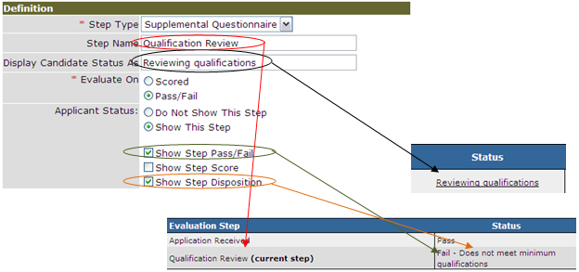
You can edit these steps at any time throughout the recruitment process. You may want to set them up to show all this information when you first create the exam plan, or you may want to leave them on ‘Do Not Show This Step’ until after you have processed the candidates.

